**Simple Visitor Use case** :

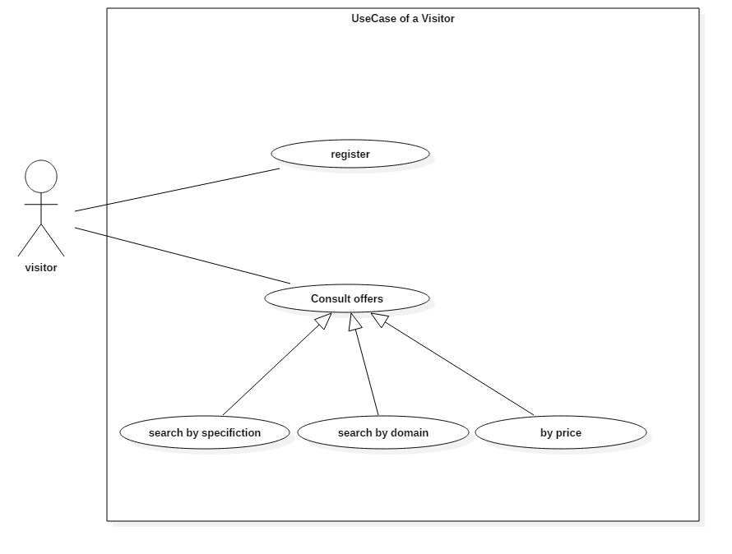

|  |  |
| --- | --- |
| Use Case | Description |
| Register | The visitor have the right to register to the website and become a member  Actor : Visitor  Precondition : none  Main event flow :  1-Select register bottom and fill in the registration form  2- Confirm register via mail |
| Consult offers | The visitor can consult the different available offers  Actor : visitor  Precondition : none  Main event flow :   1. Consult catalog 2. Effect searches with options |

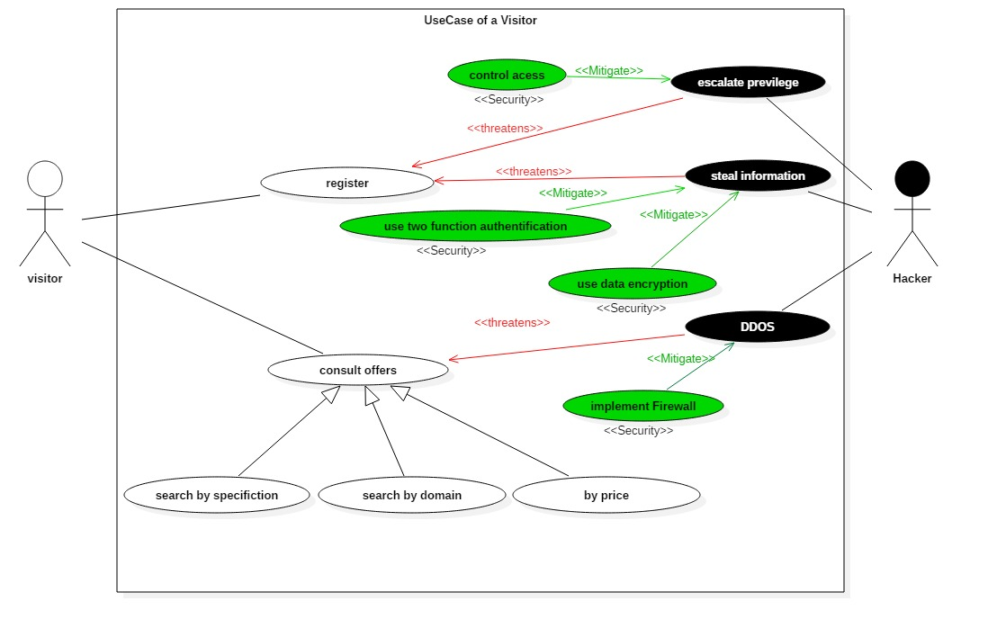**Secure Visitor Use case :**

|  |  |
| --- | --- |
| Misuse Case | Description |
| Escalate privilege | The Hacker can use the mise use configuration and some brute force program to escalate privilege during the register phase  Actor : Hacker  Precondition : existed vulnerability  Mitigation: implement control access |
| Steal information | The hacker can use some sniff technique to steal important information during the register phase  Actor : Hacker  Precondition : unsafe data  Mitigation : use data encryption like SSL  use secure traffic https |
| DDOS | The hacker can DDOS the website via performing many request during consultation  Actor : Hacker  Precondition : existed vulnerability  Mitigation : implement Web Application Firewalls  Implement Web application filter |

**Simple Client Use case** :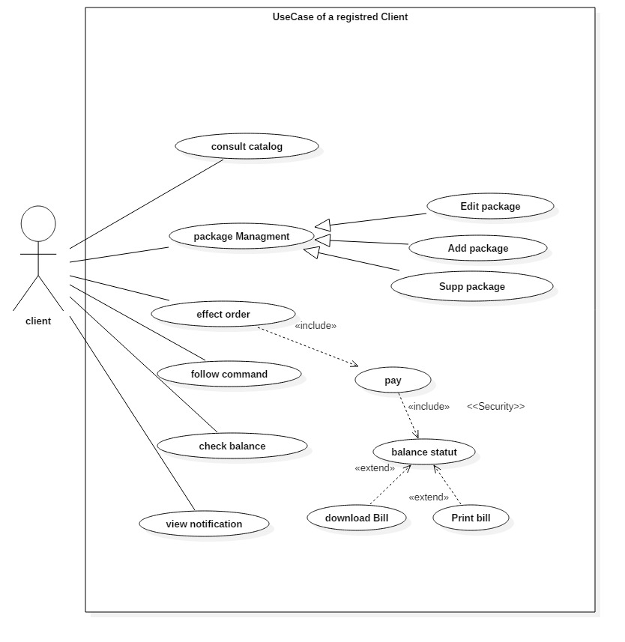

|  |  |
| --- | --- |
| Use Case | Description |
| Consult catalog | The client can consult the different available offers  Actor : Client  Precondition : authentification  Main event flow :   1. Consult catalog 2. Effect searches with options |
| Package managment | The client can manage his offers and package throw add an offer or delet it or make a modification  Actor : client  Precondition : authentification  Main event flow :   1. Select package button and consult the running offers 2. Add an offer throw add button or delete it or make modificiation |
| Effect order | The client effect order by choosing one of the presented offers in the catalog  But his must ensure that his balance status is not empty and can afford the offer also he can download a bill or print it  Actor : client  Precondition : authentification ,balance status not empty  Main event flow :   1. The client select offers 2. Start it if the balance status is not empty 3. Choose to download or print a bill |
| Follow command | The client can follow his command and consult the time he passed with his offers and haw many money he spent  Actor : client  Precondition : authentification  Main event flow :   1. Select follow command 2. Consult consummation and status per offer |
| Check balance | The client can check his balance and decide to implement it if he need throw a transaction generated from outside the website  Actor : client  Precondition : authentification  Main event flow :   1. Check balance 2. View wallet id and when money will achieve |
| View notification | The client can view notification send it by the admin and the website  Actor : client  Precondition : authentification  Main event flow :   1. View notification 2. Contact the admin for support |

**Secure Client Use case** :

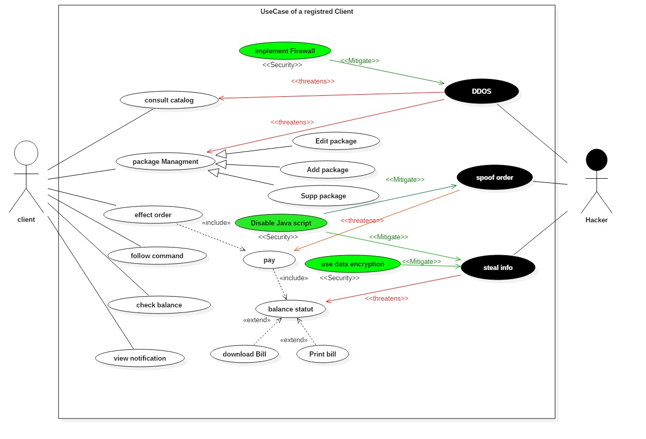

|  |  |
| --- | --- |
| Misuse Case | Description |
| Escalate privilege | The Hacker can use the mise use configuration and some brute force program to escalate privilege during the register phase  Actor : Hacker  Precondition : existed vulnerability  Mitigation: implement control access |
| Steal information | The hacker can use some sniff technique to steal important information during the register phase  Actor : Hacker  Precondition : unsafe data  Mitigation : use data encryption like SSL  use secure traffic https |
| DDOS | The hacker can DDOS the website via performing many request during consultation  Actor : Hacker  Precondition : existed vulnerability  Mitigation : implement Web Application Firewalls  Implement Web application filter |



**Simple Admin Use case** :

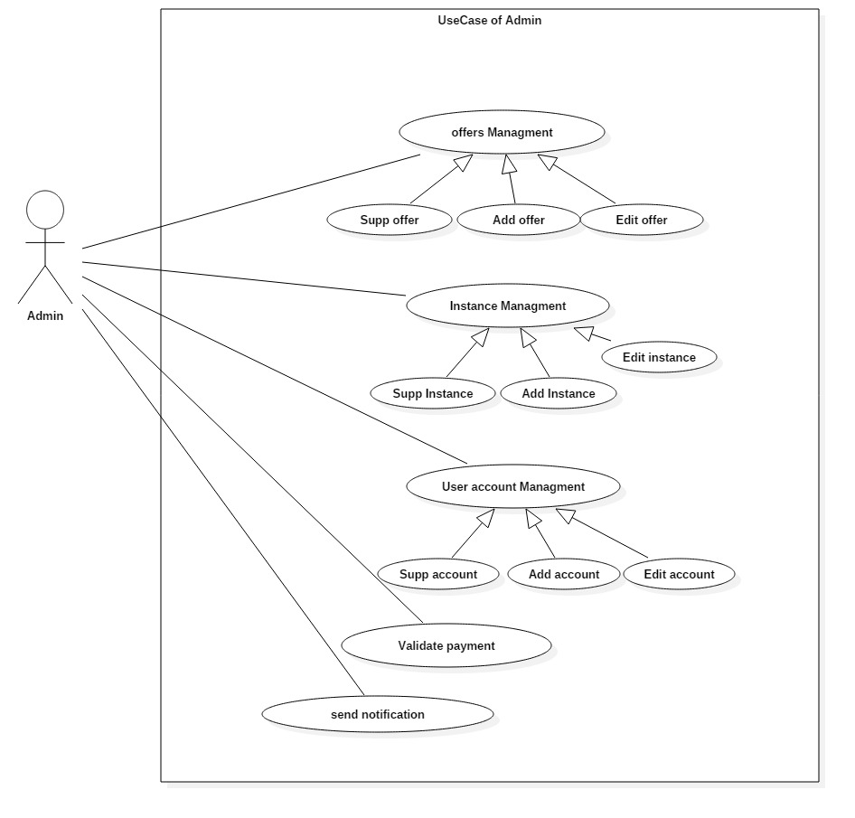

|  |  |
| --- | --- |
| Use Case | Description |
| Offers managment | The admin can manage an offer by adding or deleting or edit it  Actor : admin  Precondition : authentification  Main event flow :   1. Add offer 2. Edit offer 3. Delete offer |
| User account management | The admin can manage the users account throw adding deleting or edit the information  Actor : admin  Precondition : authentification  Main event flow :   1. Add user 2. Edit user 3. Delete user |
| Validate payment | The admin can validate the payment either manual or automatic when he received the transaction  Actor : admin  Precondition : authentification  Main event flow :   1. Check transaction 2. Validate payment |
| Send notification | The admin can send notification to the users and contact them  Actor : admin  Precondition : authentification  Main event flow :   1. View users compartment 2. Contact user |

**Secure Admin Use case** :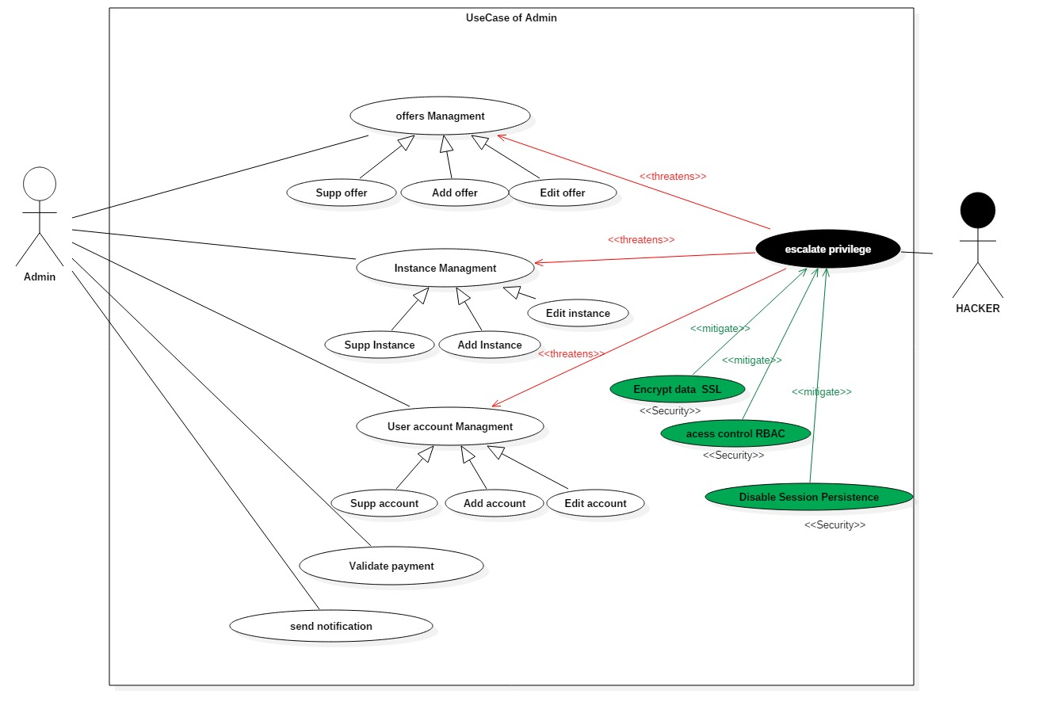

|  |  |
| --- | --- |
| Misuse case | Description |
| Escalate privilege | The hacker escalate the privilege to gain the admin roles and have an illegal access to the website  Actor : hacker  Precondition : excited vulnerability  Mitigation :   1. Use encryption data with SSL 2. Use access control RBAC 3. Disable session persistence |